Grand Canyon University

Project 1 - Find a Hidden Treasure

Justin Dietrich and Ryan Scott

CST-415: AI in Games and Simulations Lecture & Lab

Dr. Ricardo Citro

January 16, 2022

A brief description of the game or simulation (one paragraph)

1. Our game will be from a top-down view, set in an environment that has paths, walls, and other types of cover or obstacles. Things that will be there are the player, enemies, and a base or VIP to protect. The base would be in the middle and enemies would come from the edges of the environment. Your goal is to stop the enemies from destroying whatever it is you are protecting in the middle.

How are the concepts listed above relevant and its purpose? (one paragraph)

1. The game uses the concept of ‘hidden treasure’ in the sense that there are enemies trying to find their way to the center (where the thing that you’re protecting is) as well as some that are trying to find their way to you. They have to find a path that goes to their goal in an efficient way while dealing with walls. Some have to constantly calculate a path if they are finding the player, as the player constantly changes position.

Which search method will be used? (one paragraph and bullet points outline)

1. We used A\* pathfinding as our algorithm of choice. The A\* algorithm works by having a G cost (walking cost from the start node), an H cost (heuristic cost to reach end node) and an F cost which is G + H. Nodes that are queued up for searching enter the open list, whereas nodes that have been explored are thrown into a closed list. Once the end node is found, the steps are retraced and the path is found.

Example Scripts

1. Scripts: <https://github.com/AsePlayer/CST-415>

How will you overcome unforeseen obstacles during implementation? What is your 'plan B'?

1. If we can’t get the AI to properly pathfind, we could always set points on the mapwhere they shouldn’t go depending on what position they are in. We could also have it be the same map every time or have a few maps you could choose from if we are having trouble with the random generation. That would make it easier to set points on the map to guide the enemies. If it’s really bad, we could always change the premise of the game to be around what we can get working.

How is the project aligned with the current topic objectives?

1. This project essentially serves as an AI sandbox, allowing us to implement various enemies with their own unique AI quirks. For example, there are normal enemies whose primary goal is to retrieve the treasure, but there can also be zombies whose primary goal is to eat the player and bust through barricades to get to them.

What will appear on the screen: animation, user interactions, information dashboards, UI elements, etc.

1. I’m thinking that we don’t need detailed sprites to start at least, but it would be nice to have if we have time in the late stages of the project. There would be a HUD that shows your character’s health and weapons as well as a minimap, as that would be very important in a game where you need to be very aware of where the enemies are.

List the platform and software tools you plan on using

1. Stuff we will use:  
   Unity (with C# scripts)  
   Adobe Photoshop  
   Adobe Illustrator  
   MS Paint  
   Audacity

Game Concept Art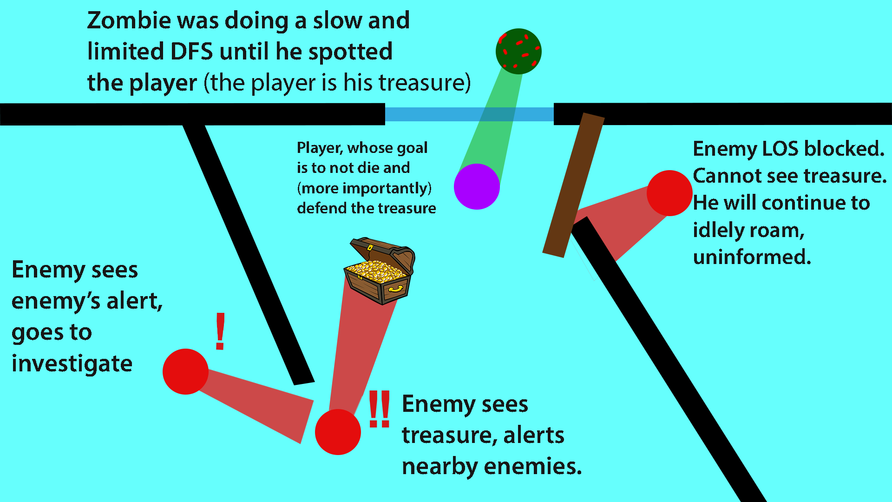

A\* Algorithm Flowchart: